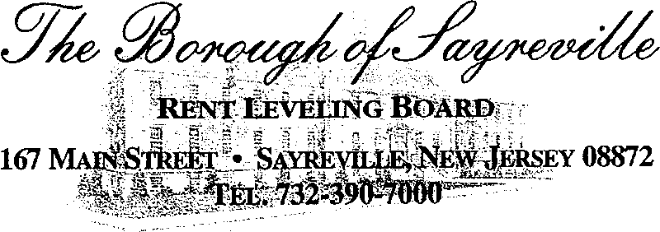

AGENDA FOR NOVEMBER 9, 2021 – 6:30 P.M. VIA ZOOM
Join Zoom Meeting
https://nyu.zoom.us/j/5718198531
Meeting ID: 571 819 8531
+1 646 558 8656 US (New York)

1. Roll Call

2. Acceptance of Minutes from October 12, 2021

3. Correspondence

4. Lease Renewals

5. Old Business

Status of Ordinance Changes

6. New Business

7. Informal Requests from Floor

8. Adjournment

